**DEVELOPMENT OF A LOW-COST LOW-PROFILE MULTICHANNEL FRONT-END EMG ACQUISITION DEVICE**

**NAZHAN HAKEEM BIN AHMAD ZAKI**

**51218118204**

**NAZHAN HAKEEM BIN AHMAD ZAKI BACHELOR OF ELECTRICAL ENGINEERING WITH HONOURS JANUARY 2022**

**UNIVERSITY KUALA LUMPUR**

**JANUARY 2022**

**DEVELOPMENT OF A LOW-COST LOW-PROFILE MULTICHANNEL FRONT-END EMG ACQUISITION DEVICE**

**NAZHAN HAKEEM BIN AHMAD ZAKI**

**51218118204**

**Report Submitted to Fulfil the Partial Requirements for the Bachelor of Electrical Engineering (Hons)**

**Universiti Kuala Lumpur**

**JANUARY 2022**

# DECLARATION

I declare that this report is my original work and all references have been cited adequately as required by the University.

Date:27/05/2022 Signature:……………………………

Full Name: NAZHAN HAKEEM BIN

AHMAD ZAKI

ID Number: 51218118204

# APPROVAL

We have supervised and examined this report and verify that it meets the program and University’s requirements for the Bachelor of Electrical Engineering (Hons.).

Date: 27/05/2022 Signature: ……………………………………

Supervisor: DR. MUHAMMAD HAZIQ

KAMARUL AZMAN

Official Stamp:

# ACKNOWLEDGEMENT

I would like to use this opportunity to express my appreciation and gratitude to my Final Year Project Supervisor, Dr. Muhammad Haziq Kamarul Azman for suggesting the topic of this research, guiding me on the research, and willingly to use his precious time to assist mee. His profound knowledge and deep understanding on the topic have helped me a lot on understanding and completing this research though our productive discussion.

Besides, my family especially my father, Ahmad Zaki Bin Idris and my mother, Hasni Binti Ishak have provided good support on me both physical and mental and always praying for my success. Finally, I am very grateful to the Almighty God that has given me the strength to do this research and because of his mercy that I am able to complete this research.

**TABLE OF CONTENTS**

DECLARATION i

APPROVAL ii

ACKNOWLEDGEMENT iii

LIST OF FIGURES viii

LIST OF TABLES ix

LIST OF ABBREVIATIONS x

ABSTRACT xi

CHAPTER 1: INTRODUCTION 1

1.1 BACKGROUND OF THE PROJECT 1

1.2 PROBLEM STATEMENT 2

1.3 OBJECTIVES OF THE PROJECT 3

1.4 SIGNIFICANT OF THE PROJECT 4

1.5 SCOPE AND LIMITATIONS OF THE PROJECT 4

1.6 CHAPTER SUMMARY 5

CHAPTER 2: LITERATURE REVIEWS 6

2.1 INTRODUCTION 6

2.2 PHYSIOLOGY OF MUSCLE FIBER 6

2.2.1 Motor Unit 6

2.2.2 Action Potential in Muscle Fiber 7

2.2.3 Generation of Action Potential in Muscle Fiber 7

2.2.4 Muscle Fiber Conduction Velocity 9

2.2.5 Anatomical Features of Muscle 10

2.3 ELECTROMYOGRAPHY (EMG) SIGNAL GENERATION 11

2.3.1 Concept of Electromyography (EMG) 11

2.3.2 Signal Source of EMG Signal 12

2.3.3 Electrode Configuration, Distance and Location 14

2.3.4 EMG Detection, Electrode Montages and Electrode Size 16

2.4 REVIEW OF PREVIOUS RESEARCH ON LOW-COST MULTICHANNEL ELECTROMYOGRAPHY (EMG) 17

2.4.1 Design of a Low-Cost Wireless Surface EMG Acquisition System[5] 17

2.4.2 Low-Cost Hardware and Software Platform for Multichannel Surface Electromyography[4] 18

2.4.3 Design Of a Real Time Portable Low-Cost Multi-Channel Surface Electromyography System[6] 19

2.4.4 Low-Cost Wearable Multichannel Surface EMG Acquisition for Prosthetic Hand Control[22] 21

2.5 CHAPTER SUMMARY 23

CHAPTER 3: METHODOLOGY 24

3.1 INTRODUCTION 24

3.2 Hardware Specifications 24

3.2.1 Microcontroller: Cypress Semiconductor PSoC Development Board CY8CKIT-059 24

3.2.2 Electrodes: Disposable Electrode Pad 26

3.3 Software Specifications 26

3.3.1 PSoC Creator 26

3.3.2 SerialPlot 28

3.3.3 Microsoft Excel 28

3.4 Block Diagram 29

3.5 Flow Chart 30

3.6 Material Cost 31

3.7 Testing Methodology 31

3.7.1 Tool used 31

3.7.2 Simulation of EMG Signal Amplification 32

3.7.3 Raw Data Collection 35

3.8 Chapter Summary 35

Chapter 4 RESULT & DISCUSSION 37

4.1 Introduction 37

4.2 Electromyography (EMG) Signal Acquisition Circuit 37

4.2.1Single Differential Circuit 38

4.2.2 Bipolar Measurement Circuit 39

4.2.3 Double Differential Circuit 40

4.2.4 Combinations of three EMG acquisition circuit 41

4.2.5Circuit Configurations 42

4.3 Hardware circuit 44

4.4 Electromyography (EMG) Signal Transmission 44

4.5 Data Collection 47

4.6 Results & Discussions 48

4.6.1 Cost of the product development. 48

4.6.2 EMG Signal Acquisition Data 48

4.6.2.1 Single Differential Circuit (Mode 1) 49

4.6.2.2 Bipolar Measurement Circuit (Mode 2) 51

4.6.2.3 Double Differential Circuit (Mode 3) 53

4.6.2.4 Comparison Between the Percentage of Muscle Extraction and Average Voltage 55

4.6.2.5 Features EMG signal based on EMG acquisition circuit 56

4.7 Chapter summary 59

Chapter 5: Conclusion 1

5.1 Introduction 1

5.2 Recommendations 1

5.2.1 Develop a custom serial software 2

5.2.2 Optimize the configuration of the EMG acquisition circuit 2

5.2.3 Implement Internet of Things (IoT) 2

5.3 Chapter summary 3

REFERENCES 1

# LIST OF FIGURES

Figure 1 The action potential changes in membrane permeability to positive Natrium and Kalium ions over time[11] 8

Figure 2 The architecture of muscle fiber from proximal to distal tendon[16] 10

Figure 3 Line Source Model which represents the portion ∆Z of the fiber membrane 13

Figure 4 Differential system configuration 14

Figure 5 Double Differential System Configuration 15

Figure 6 The structure of the EMG acquisition system 17

Figure 7 The acquisition board of the EMG device 19

Figure 8 The block diagram of the EMG signal acquisition system 20

Figure 9 The circuit diagram of a single channel EMG amplifier 20

Figure 10 The structure of the EMG acquisition system 22

Figure 11 The block diagram of the EMG acquisition system 22

Figure 12 Cypress PSoC development board CY8CKIT-059 24

Figure 13 Disposable Electrode Pad 26

Figure 14 PSoC Creator features 27

Figure 15 data on column B is visualize into scatter line plot 28

Figure 16 Block Diagram of the EMG acquisition system 29

Figure 17 The flow chart of the acquisition system 30

Figure 18 The circuit diagram of single differential system 33

Figure 19 The input signal (Orange line) and output signal (green line) 34

Figure 20 Raw EMG data 35

Figure 21 Schematic diagram of single differential circuit in PSoC Creator 38

Figure 22 Schematic diagram of bipolar measurement circuit in PSoC Creator 39

Figure 23 Schematic diagram of double differential circuit in PSoC Creator 40

Figure 24 The schematic diagram of Electromyography (EMG) acquisition circuit 41

Figure 25 PWM configuration 42

Figure 26 Delta Sigma Analog to Digital Converter (ADC) 43

Figure 27 pins allocation in PSoC Creator 43

Figure 28 EMG acquisition circuit board with electrodes 44

Figure 29 the locations of the electrodes placed on the biceps of the arm 45

Figure 30 the locations of the electrodes in actual arm biceps 45

Figure 31 0% muscle extraction 46

Figure 32 50% muscle extraction 46

Figure 33 100% muscle extraction 46

Figure 34 SerialPlot interface for plotting and displaying data 47

Figure 35 Scatter line plot of EMG signal from single differential circuit (0% muscle extraction) 49

Figure 36 Scatter line plot of EMG signal from single differential circuit (50% muscle extraction) 50

Figure 37 Scatter line plot of EMG signal from single differential circuit (100% muscle extraction) 50

Figure 38 Scatter line plot of EMG signal from bipolar measurement circuit (0% muscle extraction) 51

Figure 39 Scatter line plot of EMG signal from bipolar measurement circuit (50% muscle extraction) 52

Figure 40 Scatter line plot of EMG signal from bipolar measurement circuit (100% muscle extraction) 52

Figure 41 Scatter line plot of EMG signal from double differential circuit (0% muscle extraction) 53

Figure 42 Scatter line plot of EMG signal from double differential circuit (50% muscle extraction) 54

Figure 43 Scatter line plot of EMG signal from double differential circuit (100% muscle extraction) 54

Figure 44 Bar chart of average voltage based on mode 56

Figure 45 Close up EMG signal from single differential circuit (100% muscle extraction) 57

Figure 46 Close up EMG signal from bipolar measurement circuit (100% muscle extraction) 58

Figure 47 Close up EMG signal from double differential circuit (100% muscle extraction) 59

# LIST OF TABLES

Table 1 The specification of PSoC 5LP 25

Table 2 Material cost 31

Table 3 Total cost of EMG device 48

Table 4 Average Voltage based on readings from each mode 55

# LIST OF ABBREVIATIONS

EMG Electromyography

PC Personal Computer

Op Amp Operational Amplifier

sEMG Surface Electromyography

MFAP Muscle Fiber Action Potential

MUAP Motor Unit Action Potential

MFCV Muscle Fiber Conduction Velocity

IAP Intercellular Action Potential

SVM Support Vector Machine

ADC Analog Digital Converter

SD Single Differential

DD Double Differential

# ABSTRACT

The project is mainly focus on developing a low-cost multichannel front-end EMG acquisition device to provide alternative solution for those who want an affordable option to use EMG device. As the cost of manufacturing an EMG machine can reach almost thousands of ringgits, the price of the EMG machine is very expensive, and the machine is also bulky making it not a suitable choice for someone who want to do EMG diagnosis frequently. The proposed EMG device is designed to be as simplicity as possible by only use one microcontroller that has all the requirements for an EMG device to operate. The acquisition system consists of three parts which are the EMG electrodes to detect the EMG signal from the muscle, the microcontroller that will process the EMG signal, and data monitoring which the data is transferred to PC for display. The research methodology would discuss further about its specifications and cost of developing the EMG device while also include the simulation of EMG acquisition and filtering signal.

# CHAPTER 1: INTRODUCTION

## 1.1 BACKGROUND OF THE PROJECT

In recent years, the demand of using biomedical devices has rose with the increase of the interest of people who want to receive health diagnosis depending on their health condition. The technology of biomedical devices that allow people to do self-diagnosis which is smarter and convenient has made healthcare industry more intelligent and help changing people life to become better[1]. In decades, there have been many great inventions in biomedical devices that improve the process of diagnosis the health condition of a patient. The electromyography (EMG) is one of the best findings in the medical history with the discovery of electricity generated by the nerves and muscles in the body that was found by Galvani in 1771. Although the concept of electromyography (EMG) was discovered in 18th century, it took years of experimenting and researching in the study until in 1960, the surface electromyography device was finally used for clinical uses to treat disorder related to neurological and neuromuscular disease[2].

Ever since that, the EMG devices has become an essential biomedical device for monitoring, detecting, and analysing the signal of the muscle activity. The EMG signal is a signal of neuromuscular activities in a form of electrical current generated in the muscle. The surface electromyography (sEMG) helps the neurologists and psychologists to analyse the EMG signal with advance technique of analysing and classifying the pattern of the signal using artificial intelligent and machine learning. The analysing technique has enabled a lot of potential in developing the EMG device for certain applications to do special diagnosis for to identify specific disease[3].

The disadvantage of the EMG system is that the commercial EMG device can be very expensive and bulky with a few single channels which not everyone can afford to use it for diagnosis their health condition[4]. Thus, the development of low-cost low profile multichannel front end EMG acquisition device can surely give a lot of benefits especially for the people who want to use cheaper option with the high-quality performance and comfortable to use.

## 1.2 PROBLEM STATEMENT

Currently, the electromyography system that is developed in the medical devices industry has advance specification which allows it to have the features of high-performance monitoring system, low noise, fast scanning, integrated software, and high-speed data collection. The EMG machine is used for clinical used as it can obtain EMG signal accurately due to its high specifications. However, the cost of buying one EMG machine can cost thousands of Ringgit Malaysia as the manufacturing of the EMG machine is high due to it uses many high-quality hardware components and software integration. Therefore, the cost of diagnosing using the EMG machine surely will be high and unaffordable to patient who must diagnose his muscular problem frequently.

Furthermore, there is also portable EMG device that allows the patient to monitor his neuromuscular health without connecting to the PC. Nevertheless, the portable EMG device has only one or two channels that can be used which more channels are needed to simulate more recording channels. Besides, the EMG machine has up to four channels, but the acquisition system has become bulky as it has more components on the acquisition board and the board also becomes more complex to maintain its high specification and efficiency.

## 1.3 OBJECTIVES OF THE PROJECT

The objective of the project can be found as below:

1. To develop a low-cost EMG device that has multichannel features to allow the patient to record the EMG signal on multiple channels simultaneously. The cost of the EMG device can lower by using low-cost components especially on the microcontroller which can be replaced with an all-in-one integrated circuit that is much cheaper.
2. To create an acquisition system with low complexity as low as possible but still maintaining the quality of the performance and specification with standard requirements. The acquisition system will become smaller and more comfortable to be used by the patient as it will become portable
3. To add a real time monitoring system to monitor and display the EMG recordings on the PC for visualization. The visualization on the data collected from the EMG can help the patient to observe his muscle activity and analyse the pattern for diagnosis.

## 1.4 SIGNIFICANT OF THE PROJECT

The research of developing low-cost multichannel electromyography has already been done by many researchers recently. Their research has shown that it is possible to develop an acquisition EMG system using development kit microcontroller like Arduino and National Instrument microcontroller[4]. The microcontrollers which available in the market are mostly new and have the minimum specifications to develop the EMG device. The microcontrollers are also sold with reasonable price, and it can connect with many sensors if they don’t have it embedded in them. The performance of the EMG device which was developed using the microcontroller was quite impressive as the data collected has high accuracy and can be used for pattern recognition[5].

The development of EMG device using the development kit microcontroller can be advanced as it allows the data transferred to the connected device like pc and smartphone to show real time monitoring system through Bluetooth connection[5]. By applying the machine learning models like support vector machine (SVM), the raw data collected can be analysed deeply to classified the EMG signal and its accuracy[6]. These methods prove that the EMG device can be developed with an alternative option which is cheaper and has good features in data collection and data analysis.

This project will be designed with simpler acquisition circuit by using integrated circuit that have all in one specification to make the device smaller and cheaper. The performance of the EMG device will be maintained as standard as possible to ensure the accuracy is good and can give benefits to the user experiences.

## 1.5 SCOPE AND LIMITATIONS OF THE PROJECT

The scope of this project is focus on developing low-cost multi-channel EMG acquisition device. The EMG device will be designed as low cost as possible but still have the standard specification of a standard EMG device. The cost of the EMG device is supposed to be affordable for the patient or anyone who want to own an EMG device for research purpose. The acquisition board of the EMG device will be designed with simplicity to avoid bulky board and make the device smaller.

The scope of this project will be limited to the specification and feature of the EMG device due to the low specification of the components used in the acquisition system which they might lack of some features that available in the EMG machine. Since the project is mainly design a simple EMG acquisition circuit, the components used will be limited. The microcontroller of the EMG device must have all in one specification for an EMG device to operate well to ensure it can perform at standard performance with a simplified circuit.

## 1.6 CHAPTER SUMMARY

In conclusion, this chapter briefly explained the whole content of the research on developing low-cost multi-channel EMG acquisition device. This chapter will give the idea of the objectives of this research, the problems that are highlighted in this research, the significance of this research, the scope and limitation of this research. The background of the research is explained to the reader in the first part of the chapter to give the information on the background of electromyography (EMG) and the purpose of this research. Then, the problem statement highlights the issues of the cost of the EMG machine which is very expensive and the importance of solving this problem to reduce the cost of having diagnosis using the EMG device. Next, the objective of the research is presented in the third part of the chapter. The third part presents the objectives that will be the guide of this research and need to be fulfilled in the end of the research. After that, the significance of the research is explained to highlight the contribution of this research and the importance of developing low-cost multichannel EMG device to the neuromuscular patient. The last part of this paper covers the scope and limitation of this research which slightly cover the planning of the research and state the challenges and problems that may be faced when conducting this research.

# CHAPTER 2: LITERATURE REVIEWS

## INTRODUCTION

This section will provide and discuss the information collected from academic references and research papers on the concept of the electromyography. This would help the researchers to get better understanding relating to the title. The current research is on the development of low-cost low-profile multichannel front-end EMG acquisition device which a project focussing on developing an electromyography device with low-cost and multichannel monitoring system. There are many researchers have interested in advancing the electromyography technology to obtain the benefits of obtaining the signal from the electric field produced by the muscle extraction. The EMG can help human to collect useful data that can give more convenient interactive tool for human-machine interaction interface that will be used in biomimetic control applications[5]. The EMG may provide many important applications however, it also has many limitations which the device can be expensive due to high quality of equipment to produce best results[7].

## PHYSIOLOGY OF MUSCLE FIBER

### 2.2.1 Motor Unit

Motor unit which is a motoneuron or anything that relates with muscle fibers, is the skeletal muscle’s basic functional units[8]. The activity of the motor unit is created by the discharge (firing) pattern of the motor unit that is determined by the net current induced in the motoneuron which located at the last point of descending and reflex input in the muscle fiber. A human has a number of motor units per muscle in a range of 100 for a small hand muscle to 1000 or above for bigger limb muscles[9]. The strength of the muscle contraction in the central nervous system can be increased by the larger number of active motor units and higher firing rate (firing frequency) for each motor units[10].

### 2.2.2 Action Potential in Muscle Fiber

The muscle tissue is surrounded by ionic medium and a membrane called sarcolemma which has the thickness of 75 angstroms(Å)[11]. The membrane potentials or electrical gradients can be found in all living cells in their membranes depending on the positive and negative charges ions in it. The inside of the membrane contains -60 to -90 mV with respect to the outside which it is used by neurons and muscle cells to produce electrical signals by managing the movement of the charged ions in the membrane and this process can generate electrical current.

The current produced by the movement of ions across the membrane which can be called ion channels, create the basic principle of neural signalling and muscle contraction[12]. When the depolarization of the muscle fiber produces 10 mV or above, a muscle fiber action potential (MFAP) or action potential is produced by the membrane potential. The action potential is also called as a certain type of electrical signal which can move through a cell membrane as a wave. The action potential can be generated by the neurons and muscle fiber cells which the cells have the properties of being excitable electrically. Since the signal is transported in form of wave, the transmission of the signal can be fast and travel in long distances.

### 2.2.3 Generation of Action Potential in Muscle Fiber

The action potential is created when the positive Natrium ions permeability increase, and the positive Natrium ions move into the cells which change the polarity of the cell into 10 mV positive. Since the permeability of positive Natrium ions increase, the membrane permeability to positive Kalium ions also increase which make the membrane overflow with positive Kalium ions and turn membrane potential back to its resting state like in the Figure[11].

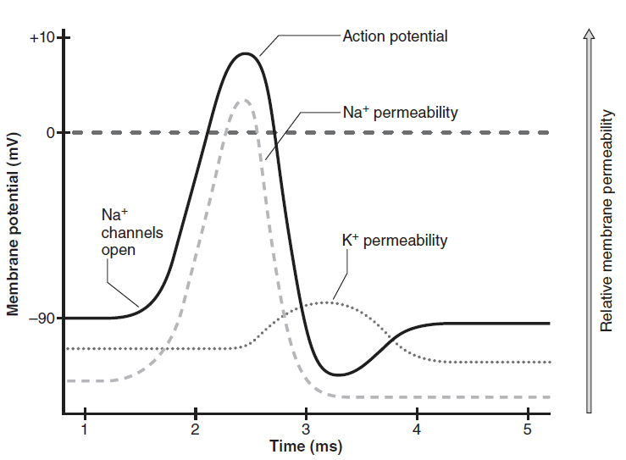

Figure 1 The action potential changes in membrane permeability to positive Natrium and Kalium ions over time[11]

When the positive Natrium ion channel open due to the increase of its permeability, the action potential increase significantly until it reaches its peak 10 mV positive. Later, the action potential has a major drop as the positive Kalium ions increase its permeability to move into cell across the membrane. The permeability of the Natrium is controlled over time during the generation of action potential. When the refractory period occurs based on the nerve or muscle impulse, the excitability of the membrane decreases and closes the positive Natrium ions channel during the period. Then, the relative refractory period occurs which the positive Natrium ions channels are open to generate the action potential back until the amount is large enough to exceed the threshold of the needed action potential.

The termination of the action potential at the muscle tendon junction can cause a terminal wave that is the main spike portion of the muscle fiber action potential (MFAP). After the main portion of the action potential, the membrane potential drops back to the normal baseline which take a long-time course and it is called slow afterwave. The slow afterwave cause the action potential in the muscle fiber to be in negative phase due to the T-tubule system repolarizes. The slow afterwave has the frequency of 2 to 40 Hz band and requires the EMG signal to be filtered in high pass filter to lower the signal[11].

### 2.2.4 Muscle Fiber Conduction Velocity

The conduction velocity of the action potential generated in a muscle fiber is called muscle fiber conduction velocity (MFCV)[13]. Since the surface EMG measures the action potential of motor unit in the muscle fiber, the measurement can be influenced by the features of the conduction velocity in the muscle fiber which the characteristics are intramuscular pH, temperature, diameter, length, muscle fatigue and neuromuscular pathology[11].

The MFCV decreases when the concentration of the extracellular positive Kalium ions increases and decreases if the intracellular pH becomes lower. The temperature of the MFCV can affect its conduction velocity which it is direct proportional to the temperature in the muscle fiber, generally increasing when the temperature is high and decreasing when the temperature is low. Muscle fiber with bigger diameter and longer length has more motor unit than smaller diameter and shorter length as bigger number of motor unit will increase the MFCV. Besides, MFCV can also increase when doing exercises or any activity that involve many muscles extraction and contraction as it can rise the temperature in the muscle fiber. Finally, if a person is diagnosed with neuromuscular or motor neuron disease, the sickness tend to reduce the conduction velocity in the muscle fiber[14].

### 2.2.5 Anatomical Features of Muscle

Electromyography (EMG) can be used in a technique for observing the muscle movement, studying the mechanisms of the muscle contraction, and detecting neuromuscular disorders. The electromyographic signal is often known as an electrical signal which the traditional signal processing technique can be used to detect the EMG signal. The EMG signal can be affected the anatomical and architectural features of muscle which the muscle has variations of length, type composition, partitioning and distribution of sensory receptors.

The length of muscle fibers can be vary as they are short and located in at proximal, distal, or middle portions of the muscle[15]. The figure 1 shows the muscle fibers from proximal(B) tendon to distal(A) tendon. The muscles in between proximal to Distal(D) tendon also have different length. The length of the muscle fiber such as in human hamstring can be in range of four to twenty centimetres in length and it will give different action potential at different portions of the muscle fibers since the surface electrodes can only measure the signal from the muscle under the electrodes[16].

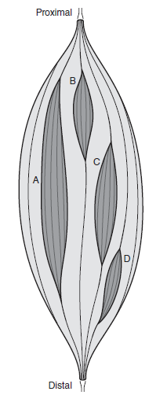

Figure 2 The architecture of muscle fiber from proximal to distal tendon[16]

The muscle fibers with deeper and more surface portions of muscle will have different characteristics as the deeper muscle can have larger proportion of slow-twitch fibers and the muscle fiber with more surface portions can give bigger proportion of fast-twitch fibers[17]. This variation in fiber type composition of the muscle can give different EMG signal that may help the classification of the signal.

The partition of the muscle affects the EMG signal as each one of them has their own function in a particular muscle[18]. The muscle fiber with many architectural divisions may have different pattern in EMG signal as each architectural division has specific pattern which enable the EMG device to be developed either to record the entire muscle or only specific muscle partition. The neuromuscular compartment which has receptors that are responsive to the activity of the motor units has their own partition in the muscle and the partition can be observed through the EMG signal.

Sensory receptor distribution within a muscle is different in other muscle. The muscle region with greater density will have larger density of receptors which can give out variation of information in the EMG signal [19]. Thus, the EMG signal can record various signal at a specific partition.

## ELECTROMYOGRAPHY (EMG) SIGNAL GENERATION

### 2.3.1 Concept of Electromyography (EMG)

Electromyography is a discipline that involves measuring the electrical signal emits from contracting muscles which can be used for monitoring, analysing, and diagnosing the muscle movement[20]. The outer muscle fiber membrane depolarizes to generate an electrical potential field that can be detected as EMG signal by surface electrodes which are positioned at a certain place on the muscle with certain distance from the sources[9]. The features of the EMG signal are determined by the volume conductor which is the tissue between the muscle that generates the signal with the surface electrode.

During muscle contraction, the electrical signal from the muscle is produced and transmitted at signal sources which usually found at the area of depolarized muscle and the electrodes which are separated by tissue or volume conductor with the signal sources, will detect the signal for EMG recording. The volume conductor will function as a special low-pass filter when transmitting the signal but the effect is not significant due to the very small distance of the signal sources with the surface electrode[9].

### 2.3.2 Signal Source of EMG Signal

The membrane resting potential can be measured by inserting the micropipette electrode into a muscle fiber. The measurement of the membrane potential can be influent by the process of flowing positive Natrium and Kalium ions through the membrane to balance the concentration. A potential gradient can be generated in a fiber when the fiber membrane at neuromuscular junction is excited due to the emission of acetylcholine in the space between nerve terminal and muscle fiber membrane. The emission is caused by the electric impulse that is propagated along the motoneuron reach its terminal. The generation of potential gradient has caused the inward current density (depolarization zone) from the neuromuscular junction to the end of the tendons. The generation of inward current density propagates an ionic transmembrane current along the sarcolemma. The fiber can represent as a thin tube as it is only a few millimeters to centimeters for fast conducting nerve fiber and the fiber thin tube can flow current axially. Thus, the circuit diagram in figure 3 which is the line source model that represent the portion ∆Z of fiber membrane is assumed which the generated transmembrane current is proportional to the second spatial derivative of the intracellular action potential (IAP). Since the decrease in potential per unit length is equal to the product of the resistance per unit length and the current flowing through the resistance, we will get the equation of extracellular and intracellular path as below:

(1)

Figure 3 Line Source Model which represents the portion ∆Z of the fiber membrane

The conservation of current can be calculated with the axial rate of decrease in the intracellular longitudinal current is equal to the membrane current per unit length as formula below:

(2)

The value of the extracellular longitudinal current can be decreased when the z value is increasing due to the decrement of the transmembrane current or loss which is carried outside by the indwelling electrodes. Below is the following formula where the p is the current flowing across the electrodes.

(3)

The transmembrane voltage can be calculated by equation 4. The first derivative can be found as in equation 5 by substituting the equation 1 into equation 4. Thus, the second derivative of the equation 5 is given as in equation 6.

(4)

(5)

(6)

The equation 6 shows that the second derivative of the transmembrane potential is proportional to the transmembrane current that is assumed in the line source model. The intracellular action potential (IAP) can be varied by simple function like analytical expression or a triangular approximation. The characterization of the IAP can be determined by depolarization phase, repolarization phase and hyperpolarizing ling after potential[9].

### 2.3.3 Electrode Configuration, Distance and Location

The electrode configuration, location and reproducibility are very important as they function a major part of EMG detection from the signal source. The monopolar configuration is not used for research application due to its sensitivity to common mode signals. The widely used configuration is the differential configuration which also known as bipolar or single differential (SD) as in Figure 4. Furthermore, the double differential configuration (DD) as in Figure 5 is used to estimate conduction velocity, limit the detection volume, reduce crosstalk, and increase sensitivity[9].

Figure 4 Differential system configuration

Figure 5 Double Differential System Configuration

The differential configuration is often the common pick by most researchers as a way to record the voltage between two points. The application of differential system (SD) and double differential system can be vary based on the output signal produced by the configurations. The SD configuration can produce half positive sinusoidal wave output signal while the DD configuration can generate full sinusoidal wave output signal.

### 2.3.4 EMG Detection, Electrode Montages and Electrode Size

The intramuscular electrodes can detect the EMG signal when attached to the surface of the skin. The closer the electrodes to the source of electric potentials, the better the reading as the current source is affected by the volume conductor in the fiber membrane. When using surface electrodes, the distance between the source and the detection points and the spatial low pass filtering effect of the volume conductor are important elements that can affect the EMG reading. The surface signal is obtained by the signal recorded on different electrodes and the signals are combined as a linear signal which its simplest form is the differential detection, the bipolar montage[9].

Based on Seniam which is research conducted by the Biomedical Health and Research Program (BIOMED II) of the European Union, the recommendation for sensor locations on individual muscles for EMG signal detection are on shoulder, neck, trunk, hand, hip, upper leg, lower leg, and foot. The recommendations are given based on the muscle anatomy like subdivision, origin, insertion, and function. The research also suggested the use of circular electrodes instead of square or rectangular electrodes as it is not possible to detect any preference. The best diameter for the circular electrode is between 8mm to 10mm as it can detect good number of occurrences[21].

## REVIEW OF PREVIOUS RESEARCH ON LOW-COST MULTICHANNEL ELECTROMYOGRAPHY (EMG)

### 2.4.1 Design of a Low-Cost Wireless Surface EMG Acquisition System[5]

|  |  |
| --- | --- |
| Title (year) | Design of a Low-cost Wireless Surface EMG Acquisition System (2013) |
| Findings | * The objective of the research was to develop a low-cost surface EMG recording system for general purpose human-machine interactive control and prosthetic system. * The system composed of three part which are surface EMG sensor, microcontroller, Bluetooth acquisition module and signal analysis module. * AD8220 was selected for the pre-amplifier. * The EMG device consisted of 4 channel surface EMG sensor connected to 16-bit ADC   Diagram  Description automatically generated  Figure 6 The structure of the EMG acquisition system |
| Pros | •Low cost 4 channel EMG system with Bluetooth module and signal analysis module.  •The data of EMG signal can be validated with success rate above 90% for gesture recognition. |
| Cons | * The system was lack of specific task EMG analysis, robust gesture pattern recognition and neuromusculoskeletal force modelling. * EMG sensor acquisition board was separated with the microcontroller. * Microcontroller must use external IC for op amp/comparator |

### 2.4.2 Low-Cost Hardware and Software Platform for Multichannel Surface Electromyography[4]

|  |  |
| --- | --- |
| Title (year) | Low-cost hardware and software platform for multichannel surface electromyography (2018) |
| Findings | * The objective of the research was to implement a low-cost multichannel surface EMG acquisition platform. * The surface EMG was composed by three major components which are the dedicated acquisition board, Tiva Launchpad board and acquisition software. The system implements 4 channel to validate the system. * The A/D conversion and USB connectivity was done by a programmable Texas Instruments Tiva LaunchPad™EKTM4C123GXL. * The board had 12 input pins allowing the connection to three acquisition boards simultaneously. Storage and exhibition of captured data was done by the acquisition software, written in Python.   A picture containing electronics, circuit  Description automatically generated  Figure 7 The acquisition board of the EMG device |
| Pros | * The research managed to suggest a surface EMG with cost only 24.30 USD with 4 channels. * 3 boards can be connected to Tiva simultaneously. |
| Cons | * USB connectivity with pc for data transfer. * EMG sensor acquisition board was separated with the microcontroller (Tiva doesn’t have op amps/comparator). |

### 2.4.3 Design Of a Real Time Portable Low-Cost Multi-Channel Surface Electromyography System[6]

|  |  |
| --- | --- |
| Title (year) | Design of a real time portable low-cost multi-channel surface electromyography system to aid neuromuscular disorder and post stroke rehabilitation patients (2020) |
| Findings | * The objective of the research was to design a real time low-cost multichannel EMG acquisition system to aid neuromuscular disorder and post stroke rehabilitation patients. * The sEMG was designed to be modular with 8 separate channels and is made to be cost effective. * The major components were electrodes connected to front end analog design, signal digitization and data storage and analysis. * An instrumentation amplifier INA 106 (U1 in figure 2) was used to amplify the differential signal. Later, the signal was further amplified in second stage through LM358DT (U2A in fig 2) and lastly converted into digital signal by LM358DT (U2B in fig 2). * Atmel SAM3X8E ARM Cortex- M3 board was used for microprocessor.   Diagram, schematic  Description automatically generated  Figure 8 The block diagram of the EMG signal acquisition system  Diagram, schematic  Description automatically generated  Figure 9 The circuit diagram of a single channel EMG amplifier |
| Pros | * The sEMG had 8 channels for EMG signal. * The EMG sensors were all in the same PCB. * The system can do data analysis on the classification and accuracy of the EMG signal. |
| Cons | * The cost was around 200 usd which was mostly from the instrumentation amplifier ICs. * USB connectivity with PC for data storage and analysis. * The accuracy was decreased with the larger number of electrodes used. |

### 2.4.4 Low-Cost Wearable Multichannel Surface EMG Acquisition for Prosthetic Hand Control[22]

|  |  |
| --- | --- |
| Title (year) | Low-cost wearable Multichannel Surface EMG Acquisition for Prosthetic Hand Control (2015) |
| Findings | * The objective of the research was to reenable the natural way of controlling the lost hand using prosthetic hand controlled by low-cost wearable multichannel sEMG. * The paper proposed an idea develop a wearable sEMG to control the prosthetic hand which has three major parts that were the sEMG acquisition board, mobile processing device and control interface to the prosthetic hand. * The otto bock 13E200 sEMG electrodes were used to pick the signals and the MSP430F5529 by Texas Instrument microcontroller would process the analog signal through its ADC pins.   Diagram  Description automatically generated  Figure 10 The structure of the EMG acquisition system  Diagram  Description automatically generated  Figure 11 The block diagram of the EMG acquisition system |
| Pros | * The acquisition and pre-processing part were moved directly in a board the patient can wear comfortably in the arm close to the set of the sEMG probes. * The data was transferred through Bluetooth connection to the mobile device. * Pattern recognition and machine learning technique were used for data analysis. * The device has 2000mAh LiPo rechargeable battery that can power up the device up to 2 days. |
| Cons | * The developed acquisition device not included electrodes was approximately 60 Euros which the system can still be simplified with cheaper components. * The otto bock sEMG electrodes was not available anymore and was expensive. |

## 2.5 CHAPTER SUMMARY

This chapter summarize the foundation and basic knowledge that relates with electromyography (EMG) which explain where the source of the EMG signal, what affect the EMG signal, how the EMG device detects the EMG signal, and what is the requirement to create an EMG device. The physiology of the muscle fiber is explained to give better understanding of motor unit, action potential, conduction velocity and anatomy features of muscle fiber which are important as they involve in producing the EMG signal. Next, this chapter describes the generation of signal generation by explaining the concept of electromyography (EMG), signal source of EMG signal, EMG detection, electrodes montages and size. Furthermore, the previous research papers on developing low-cost multichannel EMG acquisition system are also reviewed to identify their findings and compare their results by observing the pros and cons of their acquisition system. The comparison can help this research to identify any improvement that can be made on the acquisition system.

# CHAPTER 3: METHODOLOGY

## 3.1 INTRODUCTION

This section will focus on discussing the methods of planning and developing the low-cost multichannel EMG acquisition system. The most important part is deciding the specification of the acquisition system as it will affect the performance and efficiency of the EMG device. The best microcontroller which has all specifications needed to operate an EMG device will be listed in this section to discuss why it is the best choice in term of cost, performance, and features. The hardware and software that are used for this development will be included in this section. The block diagram and flowchart are constructed to give better explanation on how the acquisition system works with detail information from the beginning of the system until it ends. The material used in the EMG device will be listed with low price as low as possible to reduce the cost of producing the EMG device. With proper planning and method on developing the acquisition system, the actual product can be ensured with good performance and can achieve the objectives of this project.

## 3.2 Hardware Specifications

### 3.2.1 Microcontroller: Cypress Semiconductor PSoC Development Board CY8CKIT-059

Figure 12 Cypress PSoC development board CY8CKIT-059

The development board CY8CKIT-059 PSoC 5LP is a prototyping kit by Cypress to be used for development platform and a solution for low-cost embedded application. The most important part of this board is that it uses the PSoC 5LP architecture which has wide application due to its unique specification that has many features. The kit is programmable using Cypress KitProg that allows on-board programming, debugging, and bridging functionality. The development board comes with two boards that are combined and can be separated by snapping the board. Both boards have the PSoC 5LP prototyping kit. In figure 12, two boards are stick together by a thin built-in perforated edge. The left board is KitProg board that is used for program and debug the target PSoC 5LP device. The board at the right of the development board is the target board which will be the main board for product prototyping.

The main highlight of this microcontroller is the PSoC 5LP that uses 32-bit Arm Cortex-M3 CPU. The PSoC 5LP has configurable analog and digital blocks which allow wide logic resources and complex analog signal flows. The analog blocks consist of op-amp, comparator, ADC, DAC and switch capacitor that will fulfil the requirements for this project. Below is the specifications of the PSoC 5LP[23]:

|  |  |
| --- | --- |
| **Specification** | **PSoC 5LP** |
| Core | Arm-Cortex M3 |
| Max CPU Speed | 80 MHz |
| Flash/SRAM (kB) | 256/64 |
| ADCs | 1x20-bit Del-sig  2x12-bit SAR |
| DAC | 4 |
| Comparators | 4 |
| SC/CT Analog Blocks | 4 |
| Op-amps | 4 |
| Universal Digital Blocks | 24 |
| GPIO | 62 |

Table 1 The specification of PSoC 5LP

### 3.2.2 Electrodes: Disposable Electrode Pad

Figure 13 Disposable Electrode Pad

The disposable electrode pad has the diameter of 52 mm which is suitable for adult use. The material use for the pad is non-woven that will make it wearable at any position of muscle in the body. The pads are very cheap and can be bought in large quantity.

## 3.3 Software Specifications

### 3.3.1 PSoC Creator

PSoC Creator is an integrated Design Environment (IDE) that allows for simultaneous hardware and firmware modification, compilation, and debugging of PSoC series. The IDE has revolutionary hardware and software co-design which are made possible by a library of pre-verified and pre-characterized PSoC components. All the Cypress microcontrollers are supported by the latest version of PSoC Creator which enables users to easily build their applications on any Cypress microcontroller and provide flexibility to their systems based on the specifications of the used microcontroller. The project created in the IDE consists of schematic diagram, pins allocations, clocks configurations, analog connection and C language files that provide features to the user which you can:

1. Build the hardware system design in the main design workspace by dragging and dropping components.
2. Create your application firmware in collaboration with the PSoC hardware.
3. Use configuration tools to configure components.
4. Discover the library of over 100+ Components.
5. Assess the component datasheets

Figure 14 PSoC Creator features

To build a project into the microcontroller, after building the system by designing the schematic of the system, allocating the pins on the microcontroller, configurating the system and coding the operation of system, the user can program the project into the PSoC microchip to integrate the project in the microcontroller. The IDE also provide useful example project with application notes that the users can test and review the example project into their project. Cypress has a very cooperative and responsive customer support which the user can ask about the product and project on their website. The Cypress website is a great platform to create and join a discussion about project that involve their microcontroller as it has forum platform that enables user to discuss their problems with the community. Their technical supports who consist of their application engineers and staffs can assist the user to solve their problems and provide great solutions on the project.

### 3.3.2 SerialPlot

SerialPlot is a software for plotting data from serial port in real-time. The software support three types of data input which are the simple binary stream, ASCII data, and user defined custom frame format. The software allows user to set the gain and offset of the output after obtaining the data from the serial port. It supports up to 10, 000 number of lines in its serial print window and the data can also be recorded in txt format. This software is suitable for this project as it can withstand fast data transfer from the serial port and shows real-time plot of the output.

### Microsoft Excel

The spreadsheet software, Microsoft Excel is used for storing and visualizing the collected data which is copied from the SerialPlot. Excel contains useful features and tools that help user to organize data manipulation, create statistical calculation, visualize the data in various graphs and construct tables. The software support generating various form of charts and graphs from a specified groups of cells and the parameters of the visualization chart can be easily changed to assist user to custom their charts. The figure below shows the data in column B is highlighted and visualize into scatter with straight line chart. The chart also has the options to change the design of the chart, add title for the chart and axis, add other data and more.

Figure 15 data on column B is visualize into scatter line plot

## 3.4 Block Diagram

The figure 14 shows the block diagram of the EMG acquisition system. The acquisition system consists of three parts which are multi-channel EMG electrodes that detects the EMG signal from the muscle, the microcontroller that control the device and the data monitoring and analysis module that will display the data from the microcontroller and do data analysis. There are four EMG electrodes that will make four channel EMG signalling. The raw data from the EMG electrodes will be sent to the microcontroller, PSoC development board CY8CKIT-059 before sending the data to PC through USB connection for data monitoring and analysis.

Figure 16 Block Diagram of the EMG acquisition system

### 3.5 **Flow Chart**

The flow chart of the acquisition system can be found in figure 15. The system starts when the EMG device is activated. The EMG electrodes will be placed on the muscle on the body and acquire the EMG signal before sending the signal to the microcontroller CY8CKIT-059 to process the raw data of EMG signal for signal filtering process. The filtered EMG signal is generated and transferred to the PC through USB connection for data storing, monitoring and analysis.

Figure 17 The flow chart of the acquisition system

### 3.6 **Material Cost**

|  |  |  |
| --- | --- | --- |
| Material | Unit | Cost (RM) |
| PSoC CY8CKIT-059 | 1 | 80.26 |
| Disposable Electrode Pad | 20 | 5.70 |
| Electrode Wires | 2 | 70.00 |
| Resistors (1k & 20k ohm) | 16 | 2.40 |
| Capacitors (10nF) | 8 | 1.00 |
| Breadboard | 1 | 2.50 |
| Total | | 161.86 |

Table 2 Material cost

Table 2 shows the cost of materials used in the EMG acquisition system. The disposable electrode pads are very cheap and can be bought in bulk quantity for testing purpose. The wires used are bought based on its connection with the electrodes which require circular female connector. The overall cost of the acquisition system is RM 88.96 which is a very cheap price for an EMG device.

### 3.7 **Testing Methodology**

In this topic, the methodology of amplification and filtering the EMG signal from a simulation and raw source are tested to get simulated result that can be used as expected result when conducting the actual testing. The topic is discussed further in the subtopics below.

### 3.7.1 Tool used

1. NI Multisim

NI Multisim is a simulation program for electronic circuit design and simulation. The program offers various types of electronic components that can be used for circuit design and simulation. For this project, Multisim is used to design the single differential amplifier to test the proposed circuit to acquire the EMG signal from its source.

1. MATLAB Simulation

MATLAB is a programming and simulating platform that is mainly used for data analysis, algorithm development and model creation. The platform provides many types of toolboxes for various purposes to help researchers conducting their testing and research more effectively using computer processing and simulation[24]. Thus, MATLAB is used as the platform in this testing to install one of its toolboxes for EMG simulation.

1. EMGLAB

EMGLAB is a MATLAB toolbox that can filter raw EMG data into filtered EMG signal and decompose them into MUAP trains and averaging MUAP waveforms. The converted data will be display into a convenient graphical interface for better visualization and data analysis. The toolbox has advanced algorithms for template matching, resolving superimpositions, and decomposition-triggered averaging[25].

### 3.7.2 Simulation of EMG Signal Amplification

For this discussion, the single differential system is constructed using NI Multisim to test the differential amplifier circuit to amplify the EMG signal from the EMG source that is detected by the EMG electrodes. The circuit of single differential system that consists of single differential amplifier is designed in NI Multisim to simulate the single channel of the EMG acquisition system as in Figure 16.

Figure 18 The circuit diagram of single differential system

In Figure 16, the INA105 op amp is used as the differential amplifier due to its high precision op-amp and accurate gain. The R3 is acted as the skin resistor and the positive electrode that will flow the EMG source, and voltage reference are connected to the resistor. Function generator is used to generate input signal of 1 Hz, 10mV to the EMG electrode. The differential system will differentiate the two inputs and amplify the output signal at gain of 1.1[26]. The input signal and the output signal are connected to oscilloscope to observe the signal wave.

Figure 19 The input signal (Orange line) and output signal (green line)

The input signal and output signal can be seen in Figure 17 which the input is coloured orange and output signal is coloured green. The output signal is amplified by the differential system at more than ten times from the input signal due to its gain value is 1.1. The result of EMG signal amplification shows that the EMG signal can be amplified using single differential amplifier and the amplification can be increased by increase the gain or the resistance of the feedback resistor.

### 3.7.3 Raw Data Collection

Figure 20 Raw EMG data

The raw EMG data is obtained from a repository of medical research data, PhysioNet website. The data were collected using 25mm concentric needle electrode and were recorded at 50 kHz and then down sampled to 4kHz. Two analog filters were used during the recording process which are 20 Hz high-pass filter and a 5 kHz low-pass filter. The EMG data is collected from a 44-year healthy old man[27]. The figure 18 shows the raw EMG data is visualized using MATLAB.

## 3.8 Chapter Summary

In conclusion, this chapter discusses the plans and methods of developing the low-cost multi-channel EMG that consists of hardware specifications, block diagram, flow chart and material cost. The specifications of the EMG device can be referred to the hardware specifications that has the details of the acquisition system. The block diagram and flow chart visualise the idea on how the system operates to give better understanding to the people about the EMG device. To manage the cost of developing the EMG device, the details of materials used for this project is listed in the material cost and the materials used are selected with low price as low as possible with good specifications. Thus, the objectives of developing a low-cost multi-channel EMG acquisition system can be achieved with good planning of selecting good low-cost materials and suitable methods.

# Chapter 4 RESULT & DISCUSSION

## 4.1 Introduction

This section will highlight the schematic diagram of the EMG acquisition circuit and the result of the low-cost multichannel EMG acquisition system development. The schematic of three EMG acquisition circuits is introduced to explain the components and their function in the circuits. The prototype electromyography (EMG) acquisition circuit that has the combinations of three acquisition circuit are discussed on how it can be integrated into the microcontroller. The configuration of the circuits is described to give information on the setting of the components in the circuits. The results will consist of various reading of EMG signals from different muscle extractions to compare the reading. The features of each acquisition circuit will be discussed, and the EMG reading will be analyzed to evaluate the performance of the low-cost EMG device. The details of cost to build the EMG device prototype is listed which include both hardware and software cost for the project. The results are discussed on the data obtained from each circuit with three method of muscle extractions. The objectives of the low-cost low-profile multichannel front-end electromyography (EMG) device are justified in this section.

## 4.2 Electromyography (EMG) Signal Acquisition Circuit

The low-cost low-profile multichannel front-end electromyography (EMG) device is integrated with three types of EMG signal acquisition circuit which are mainly built based on single differential, bipolar measurement, and double differential circuit. The schematic design of the circuits is designed on the PSoC Creator which the software has a library of hundreds of components, and it will display the components available in the targeted microcontroller. The figures below show the schematic diagram of the single differential, bipolar measurement, and double differential circuit that are built in the PSoC Creator software.

### 4.2.1Single Differential Circuit

Figure 21 Schematic diagram of single differential circuit in PSoC Creator

The single differential circuit use only one PGA and uses debouncer component to create interrupt for analog mux switching that will switch the input of the PGA with other input electrodes. In single differential circuit, the input voltage from the electrode is substrate with the voltage reference to create an amplified voltage based on the gain set on the PGA and the value will be converted into digital by ADC_DelSig_1.

### 4.2.2 Bipolar Measurement Circuit

Figure 22 Schematic diagram of bipolar measurement circuit in PSoC Creator

Bipolar measurement circuit is built mainly on two PGAs with both the input voltages are connected to two input electrodes and both the voltage reference of the PGAs are connected to the one electrode. The AMux_1 will select channel 0 to allow the output voltage from the PGA_1 is read by ADC_DelSig_1. The AMux_1 will change to channel 1 after the ADC_DelSig_1 finish reading the output channel 0 to read the output voltage from PGA_2. After both reading from channel 0 and channel 1 are obtained, the actual output voltage is calculated with the different between voltage channel 0 and voltage channel 1.

### 4.2.3 Double Differential Circuit

Figure 23 Schematic diagram of double differential circuit in PSoC Creator

The double differential circuit has three PGAs to substrate the input two times. Both output of the first two PGAs is connected to the input terminal and reference terminal of one PGAs. The input from the electrodes will through the first differential from PGA_1 and PGA_2. The output from PGA_1 and the PGA_2 is connected to PGA_3 that will produce the second differential output voltage. In this circuit, the input voltage can undergo two times differential and amplification.

### 4.2.4 Combinations of three EMG acquisition circuit

Figure 24 The schematic diagram of Electromyography (EMG) acquisition circuit

The electromyography (EMG) acquisition circuit for this project consists of a circuit that combines the single differential circuit, bipolar measurement circuit and double differential circuit. The circuits are assigned as mode which single differential circuit is assigned as mode 1, bipolar measurement circuit as mode 2, and double differential circuit as mode 3. The mode can be switched by input the mode number into the command in the serial software. When one mode is activated, the microcontroller will enable the mode circuit to run and if there are components that are not used for that mode, the unused components are disabled to avoid disturbance on the mode circuit.

### 4.2.5Circuit Configurations

The EMG acquisition circuits are built using analog pins which are connected to electrodes, Programmable Gain Amplifier (PGA) which are used to operate differential circuit and Delta Sigma Analog to Digital Converter (ADC) component which will read the output of the differential circuit. The PGAs’ gain is all set to 1. The ADC component is connected to the Pulse Width Modulator (PWM) to set the start of conversion of the ADC with 2045 kHz clock connected to both ADC and PWM for synchronization. The ADC is configured to have the setting of 7142 SPS conversion rate, 2kHz frequency, single sample conversion mode and will read the output every time the PWM triggers the terminal count event. The figures below show the configuration of PWM and ADC components.

Figure 25 PWM configuration

Figure 26 Delta Sigma Analog to Digital Converter (ADC)

The PSoC Creator allows user to allocate the pins on the development board manually and automatically up to 68 GPIO pins. The feature of allocating the analog pins can be seen as in figure below. The analog pins used which connected to electrodes on the development board in this schematic diagram are P2[3], P2[4]. P2[5] and P1[4]. The UART uses P12[6] for receiver (RX) pin and P12[7] for transmitter (TX) pin. The switch button on the development board is connected to the P2[2] pin to act as analog mux switch.

Figure 27 pins allocation in PSoC Creator

## 4.3 Hardware circuit

Figure 28 EMG acquisition circuit board with electrodes

The EMG acquisition circuit board consists of the CY8CKIT-059 board connected to the external circuit and electrodes. The external circuit uses 10k ohm resistors which connected to 5V supply and ground to set mid voltage point and 1M ohm resistors to not load the voltage from mid voltage supply. This will allow the EMG signal from high impedance skin to flow into the EMG circuit.

## 4.4 Electromyography (EMG) Signal Transmission

For the method of EMG signal emission, different percentage of muscle extraction from the biceps of arm will be done. The input electrodes are placed on the biceps of the arm to detect the EMG signal and the reference electrode is located at near elbow or bone to act as ground. The figure below shows the locations of the electrodes on the biceps of arm. There are three type of muscle extraction to emit the EMG signal which 0% muscle extraction, 50% muscle extraction and 100% muscle extraction. The EMG readings from the three-muscle extraction are collected and the data collection is repeated with each of the three EMG acquisition circuit. The figure below shows the locations of the electrodes on the arm biceps and the percentage of muscle extractions for EMG signal transmission.

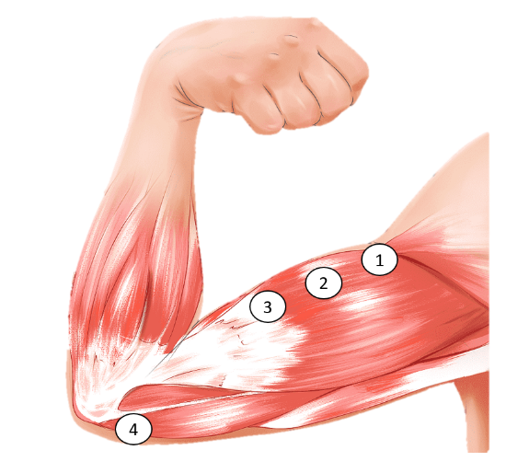

Figure 29 the locations of the electrodes placed on the biceps of the arm

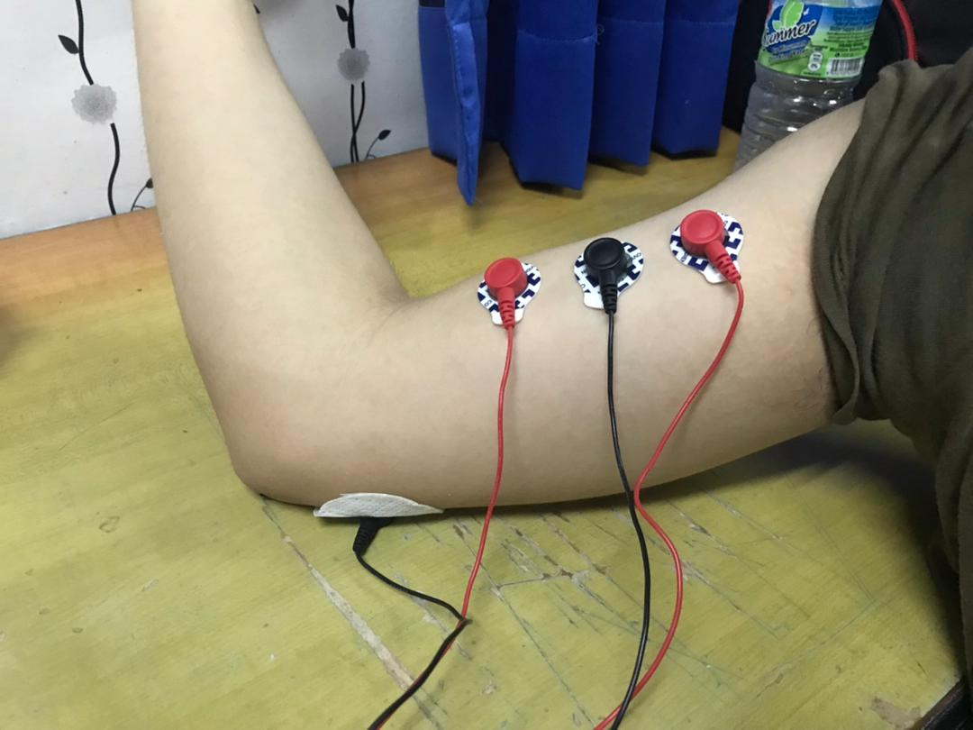

Figure 30 the locations of the electrodes in actual arm biceps

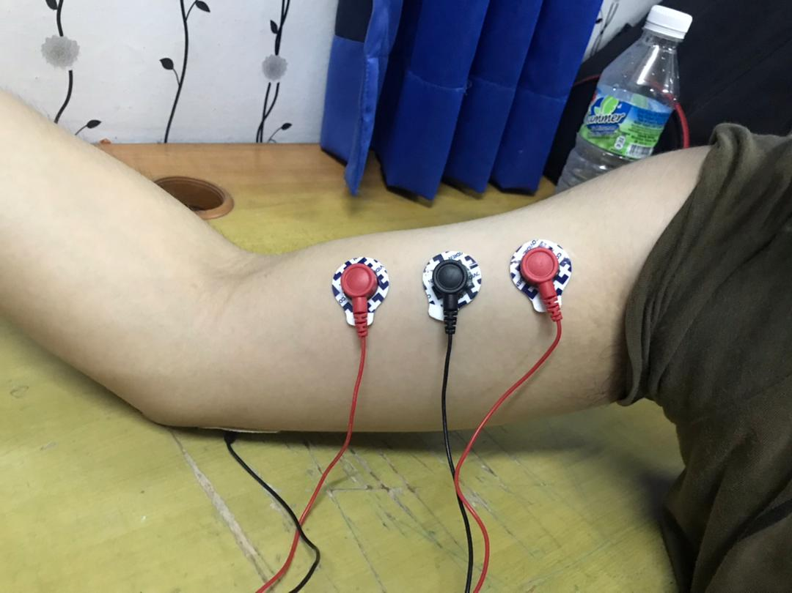

Figure 31 0% muscle extraction

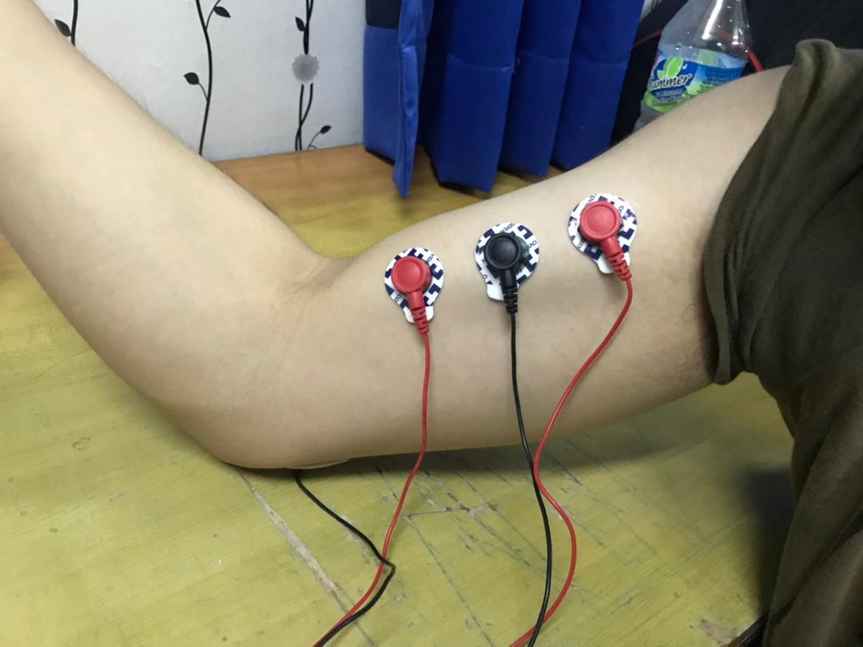

Figure 32 50% muscle extraction

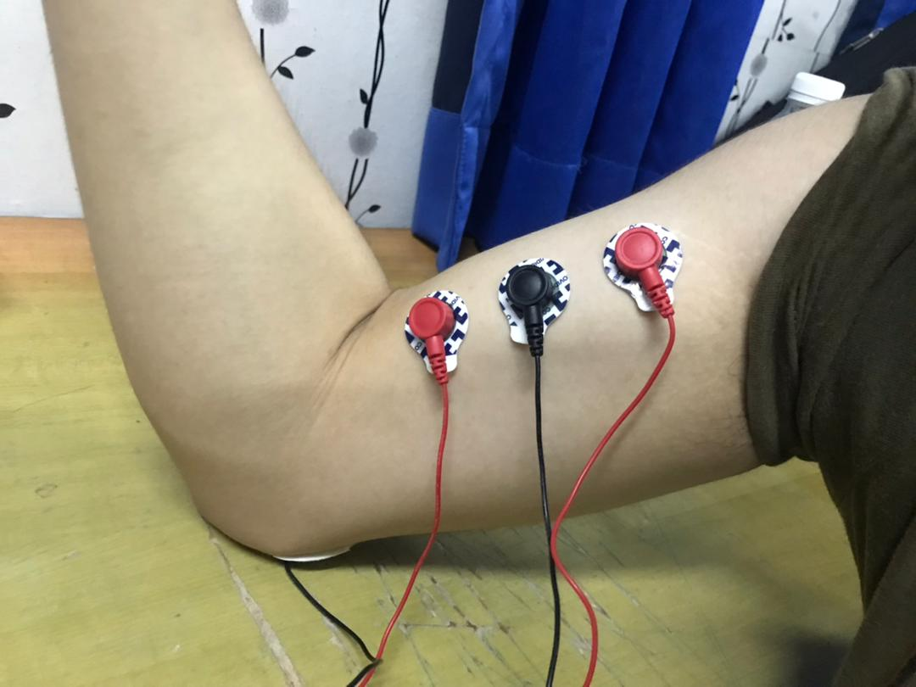

Figure 33 100% muscle extraction

## 4.5 Data Collection

The EMG signal is acquired after the EMG signal passing through the EMG acquisition circuit and is converted into digital data by ADC component in the Cypress CY8CKIT-059. The digital data is transferred to UART component to be send to the serial port. The SerialPlot software in the computer is set to connect to the serial port to receive the data and display through the serial window. The serial software can show real-time plot of the data from the EMG acquisition circuit and the displayed data can be copied up to 10,000 numbers of samples. For data collection, we will collect EMG signal data from each EMG acquisition circuit with three different percentage of muscle extraction from the arm biceps. The figure below shows the interface in the SerialPlot where the data is plotted in real-time and display the value which can be copied for data collection. The collected data will be saved into Excel software to store and visualize the data.

Figure 34 SerialPlot interface for plotting and displaying data

## 4.6 Results & Discussions

### 4.6.1 Cost of the product development.

Total cost of the electromyography (EMG) acquisition device can be seen as in table below. The cost consists of the cost of buying the microcontroller PSoC 5LP CY8CKIT-059, electrode pad, electrode cables, resistor, breadboard, jumper wires, breakout board and USB cable. The microcontroller CY8CKIT-059 can be purchased on the RS online shopping platform for purchasing electronic components which it gives the lowest price available online. The other components are purchased through Shopee online shopping platform which provides various electronic components from electronic sellers with many options of prices. The cost for software development for this project is free as all the software used in this project are available free online as the PSoC Creator can be downloaded free from the Cypress website and the Microsoft Excel is provided free by UniKL.

|  |  |  |
| --- | --- | --- |
| Material | Unit | Cost (RM) |
| PSoC 5LP CY8CKIT-059 | 1 | 80.26 |
| Disposable Electrode Pad | 20 | 5.70 |
| Electrode Cables | 2 | 70.00 |
| Resistors (10k ohm) | 6 | 2.80 |
| Resistors (1M ohm) | 6 | 2.80 |
| Breadboard | 2 | 3.90 |
| Jumper Wires | 20 | 0.90 |
| USB Cable Extension | 1 | 6.30 |
| Breakout Board | 2 | 2.20 |
| **Total** | | 174.86 |

Table 3 Total cost of EMG device

### 4.6.2 EMG Signal Acquisition Data

The EMG signal is collected from each of the three EMG acquisition circuit using three percentage of muscle extraction which are 0%, 50% and 100% muscle extraction. The acquired data is saved into Microsoft Excel and is turned into scatter line plot to visualize the data for data analysis. The figures below show the scatter line plot of the EMG signal obtained from three EMG acquisition circuit using three percentage of muscle extraction.

#### 4.6.2.1 Single Differential Circuit (Mode 1)

The single differential circuit managed to acquire the EMG signal from the muscle extraction. The EMG signal is around 50-250 mV when the arm biceps is at rest or 0%. The voltage increases when the muscle extraction increases as the 50% of muscle extraction produces 100-350 mV of EMG signal while the 100% of muscle extraction got the highest EMG value which around 150-450 mV.

Figure 35 Scatter line plot of EMG signal from single differential circuit (0% muscle extraction)

Figure 36 Scatter line plot of EMG signal from single differential circuit (50% muscle extraction)

Figure 37 Scatter line plot of EMG signal from single differential circuit (100% muscle extraction)

#### 4.6.2.2 Bipolar Measurement Circuit (Mode 2)

The EMG signal which is acquired through bipolar measurement circuit can be in range of -50 to 100 mV when the arm biceps at rest or 0% muscle extraction. The 50% muscle extraction got higher range voltage EMG signal value which is 0 to 200 mV. The EMG signal has the highest range when 100% of the muscle is extracted which is around 50 to 350 mV.

Figure 38 Scatter line plot of EMG signal from bipolar measurement circuit (0% muscle extraction)

Figure 39 Scatter line plot of EMG signal from bipolar measurement circuit (50% muscle extraction)

Figure 40 Scatter line plot of EMG signal from bipolar measurement circuit (100% muscle extraction)

#### 4.6.2.3 Double Differential Circuit (Mode 3)

The double differential circuit managed to measure the range of the EMG signal at 0% muscle extraction which produce the output voltage of around 70 – 130 mV. The output voltage value increases when the percentage of muscle extraction increases. The 50% muscle extraction has higher voltage output that is above 100 until 200 mV. The 100% muscle extraction is recorded to has the highest output voltage range which is between 140 and 230 mV.

Figure 41 Scatter line plot of EMG signal from double differential circuit (0% muscle extraction)

Figure 42 Scatter line plot of EMG signal from double differential circuit (50% muscle extraction)

Figure 43 Scatter line plot of EMG signal from double differential circuit (100% muscle extraction)

#### 4.6.2.4 Comparison Between the Percentage of Muscle Extraction and Average Voltage

The table below shows the average voltage in mV based on the percentage of the muscle extraction on arm biceps using three type of EMG acquisition circuit. The EMG signal average voltage increases as the percentage of the muscle extraction increases. When the percentage of muscle extraction increases, there are more muscle cells that are extracted to create more movement that will produce higher EMG signal. The figure below shows the bar chart that visualize the percentage of muscle extraction with average voltage data for better data analysis. The bar chart clearly shows the increase of voltage produce by the muscle when the muscle extraction is higher.

|  |  |  |  |  |  |  |  |  |  |
| --- | --- | --- | --- | --- | --- | --- | --- | --- | --- |
| Mode | Mode 1 | | | Mode 2 | | | Mode 3 | | |
| Muscle extraction | 0% | 50% | 100% | 0% | 50% | 100% | 0% | 50% | 100% |
| Average Voltage (mV) | 150.03 | 222.37 | 288.36 | 26.26 | 86.74 | 215.13 | 92.13 | 138.00 | 166.05 |

Table 4 Average Voltage based on readings from each mode

Figure 44 Bar chart of average voltage based on mode

#### 4.6.2.5 Features EMG signal based on EMG acquisition circuit

The three EMG acquisition circuit have different properties that provide different information on the EMG signal acquired from each circuit. The single differential circuit can acquire the raw EMG signal from the voltage of each electrode of the array with respect to a reference. It also can be used to create a monopolar multichannel as it can read the input of each of the array input electrodes which locate on different location on the arm biceps. The single differential detects most of the information inside the EMG signal, but it can have high noise as it is sensitive to common disturbance. The figure below shows the close-up EMG signal obtained from the single differential circuit when the muscle extraction is 100%.

Figure 45 Close up EMG signal from single differential circuit (100% muscle extraction)

The bipolar measurement circuit provides the output of the set of differential amplifiers that is acquired by measuring the difference between the adjacent channels from two amplifiers. The circuit can reduce common property which can make identification of the innervation zone easier and reduce the end of fiber effect. The EMG signal obtained from bipolar measurement circuit can be seen as in figure below when the muscle extraction is 100%.

Figure 46 Close up EMG signal from bipolar measurement circuit (100% muscle extraction)

The double differential circuit allows double differential array of signals which it takes the different between adjacent of single differential channels. The circuit can reduce unwanted signal even further which can be used for estimating the velocity of the motor unit action potential (MUAP) which is affected by the presence of unwanted signals. The figure below shows the close-up EMG signal obtained from double differential circuit when 100% of muscle extraction is used.

Figure 47 Close up EMG signal from double differential circuit (100% muscle extraction)

## 4.7 Chapter summary

This chapter addressed the characteristics of the three EMG acquisition circuits that are integrated into the PSoC 5LP CY8CKIT-059 microcontroller. The parameters of the components in the circuit are presented in this chapter. The location of the electrodes in the arm biceps and the percentage of muscle extraction are shown to explain the method of emitting the EMG signal from the muscle movement. The results from each EMG acquisition circuit based on the percentage of the muscle extraction are visualize into scatter line plot to analyse the EMG signal data better. The features of the EMG signal from each EMG acquisition circuit are explained to compare the property of the EMG signal obtained when muscle is extracted 100%.

# Chapter 5: Conclusion

## 5.1 Introduction

This chapter discusses the overall of the thesis that will validate the objectives of the study. This project aims to develop a low-cost multichannel front-end EMG acquisition device which will be an alternative solution for the person who want to measure the EMG signal affordably. The components chosen for this project are low-cost to cut the budget of building the EMG device which only cost RM 174.86 compared to the actual EMG machine that can cost thousands of ringgit. The project manages to propose a low-cost EMG device that can have three type of EMG acquisition circuit that enables multichannel features which are single differential circuit, bipolar measurement circuit and double differential circuit. The main EMG acquisition circuit is designed to integrate the three EMG acquisition circuit into one main circuit which the three circuits will be switched based on the mode assigned to each of them. This enables to reduce the bulky of the EMG device as three circuits are combined into one circuit and reduce the components used in the circuit. The serial software allows the user to monitor the EMG signal reading in real-time and display the EMG signal value that can be saved into Microsoft Excel for data collection and data visualization. The scatter line plot can be used to visualize the EMG signal to help the user to observe the muscle activity and analyse the pattern for diagnosis. This chapter also contains the recommendation for further improvement to give ideas to the reader to get better understanding on how to improve the EMG device in the future to develop greater performance of the low-cost multichannel device.

## 5.2 Recommendations

Despite the achievement of all objectives, there are still further improvements that can be done to fill the gaps and rooms in this project. The system must always be improved and innovated to ensure it can have better performance and improve user experience by providing high performance results and useful features.

### 5.2.1 Develop a custom serial software

The serial software that is used for this project can display the value and plot the graph in real-time. However, the data displayed is limited to 10000 number of samples which if the previous samples that exceed the limit number will be cleared. This means the serial software can only shows the data in the limit of 10000 samples which will be a disadvantage as the ADC component in this project uses very high conversion rate and it will miss a lot of history data. The serial software should be able to display and keep the old data while remains stable when the EMG device is running.

### 5.2.2 Optimize the configuration of the EMG acquisition circuit

The EMG acquisition circuit can still be optimized with better configurations as the current project only uses the configurations that are suggested by the reference book. The configurations of the components in the EMG device can be experimented with other configurations to compare the performance of the EMG device and find the most suitable settings that suit with the specifications of the EMG device. One of components that can be added into the circuit to improve the system is adding low pass filter and high pass filter which will limit the output in a certain range to reduce noise and unwanted signal.

### 5.2.3 Implement Internet of Things (IoT)

The internet of things can offer massive improvement to the device on the data storing, and monitoring as it can send the data obtained from a device into the connected cloud which provide large storage which it can be integrated with another device. The EMG device can transfer the data wirelessly through internet connection to the cloud storage and the user can view the data through other device like laptop or smartphone anywhere if there is excellent internet connection. The microcontroller can be upgraded by adding Wi-Fi module or use a microcontroller that already has in-built Wi-Fi module. The IoT elements can improve user experience as it can make the device portable, and it can integrate with other useful features like implementing machine learning model that can create a feature that help improving the data analysis and detection.

## 5.3 Chapter summary

In conclusion, the study of the development of a low-cost low-profile multichannel front-end EMG acquisition device has developed a prototype of low-cost multichannel EMG device using PSoC 5LP CY8CKIT-059 microcontroller that connected to four electrodes which can detect EMG signal using three type of EMG acquisition circuits which are single differential circuit, bipolar measurement circuit and double differential circuit. The data collected are based on the percentage of the muscle extraction of 0%, 50% and 100%. The results obtained from the EMG signal shows the voltage value increases when the percentage of muscle extraction increases. The EMG signal obtained from each EMG circuit also show different pattern and property. Overall, the research is considered as successful because it can achieve three objectives which to develop a low-cost multichannel EMG device, build the EMG acquisition circuits into one main circuit to reduce the size of the circuit and add a real time monitoring system which it can display the EMG signal value and plot the EMG signal in real-time. The recommendations for improvement are also included in this chapter to give ideas for further study to improve the EMG device

# REFERENCES

[1] S. W. Yuk, I. H. Hwang, H. R. Cho, and S. G. Park, “A study on an EMG sensor with high gain and low noise for measuring human muscular movement patterns for smart healthcare,” *Micromachines*, vol. 9, no. 11, 2018, doi: 10.3390/mi9110555.

[2] M. Kazamel and P. P. Warren, “History of electromyography and nerve conduction studies: A tribute to the founding fathers,” *J. Clin. Neurosci.*, vol. 43, pp. 54–60, 2017, doi: 10.1016/j.jocn.2017.05.018.

[3] I. Elamvazuthi, N. H. X. Duy, Z. Ali, S. W. Su, M. K. A. A. Khan, and S. Parasuraman, “Electromyography (EMG) based Classification of Neuromuscular Disorders using Multi-Layer Perceptron,” *Procedia Comput. Sci.*, vol. 76, no. Iris, pp. 223–228, 2015, doi: 10.1016/j.procs.2015.12.346.

[4] I. A. R. Da Silva, E. C. B. F. Dos Santos, E. M. Carvalho, and D. O. Dantas, “Low cost hardware and software platform for multichannel surface electromyography,” *Proc. - IEEE Symp. Comput. Commun.*, vol. 2018-June, no. May 2020, pp. 1114–1119, 2018, doi: 10.1109/ISCC.2018.8538663.

[5] J. Fu, J. Chen, Y. Shi, and Y. Li, “Design of a low-cost wireless surface EMG acquisition system,” *Int. IEEE/EMBS Conf. Neural Eng. NER*, pp. 699–702, 2013, doi: 10.1109/NER.2013.6696030.

[6] V. Chandrasekhar, V. Vazhayil, and M. Rao, “Design of a real time portable low-cost multi-channel surface electromyography system to aid neuromuscular disorder and post stroke rehabilitation patients,” *Proc. Annu. Int. Conf. IEEE Eng. Med. Biol. Soc. EMBS*, vol. 2020-July, pp. 4138–4142, 2020, doi: 10.1109/EMBC44109.2020.9176058.

[7] B. Koushik *et al.*, “Signal Condition and Acquisition System for a Low Cost EMG Based Prosthetic Hand,” *Lect. Notes Networks Syst.*, vol. 5, pp. 363–371, 2017, doi: 10.1007/978-981-10-3226-4_37.

[8] R. J. Monti, R. R. Roy, and V. R. Edgerton, “Role of motor unit structure in defining function,” *Muscle Nerve*, vol. 24, no. 7, pp. 848–866, 2001, doi: 10.1002/mus.1083.abs.

[9] R. Merletti and P. A. Parker, Electromyography Physiology, Engineering and Noninvasive Applications, vol. 148. 2004.

[10] F. Sandbrink and E. Culcea, “Motor Unit Recruitment in EMG,” *Electromyogr. Nerve Conduct. Stud.*, pp. 1–10, 2010, [Online]. Available: http://emedicine.medscape.com/article/1141359-overview.

[11] G. Kamen and D. A.Gabriel, *Essentials of Electromyography*, vol. 148. 2010.

[12] J. G. Betts *et al.*, “Anatomy and physiology.” 2017.

[13] M. Aliabadi, F. Hiroki, Y. Kota, A. Kazuyuki, M. Tota, and M. Naoaki, “Analysis of end-plate using multi-channel surface EMG,” *Artif. Life Robot.*, vol. 0, no. 0, p. 0, 2019, doi: 10.1007/s10015-019-00531-3.

[14] H. Ramroop and R. Cruz, “Electrodiagnostic Evaluation Of Motor Neuron Disease,” *StatPearls*, Jul. 2021, Accessed: Sep. 10, 2021. [Online]. Available: https://www.ncbi.nlm.nih.gov/books/NBK563178/.

[15] C. Gans and F. de Vree, “Functional bases of fiber length and angulation in muscle,” *J. Morphol.*, vol. 192, no. 1, pp. 63–85, 1987, doi: 10.1002/jmor.1051920106.

[16] M. I. Heron and F. J. R. Richmond, “In‐series fiber architecture in long human muscles,” *J. Morphol.*, vol. 216, no. 1, pp. 35–45, 1993, doi: 10.1002/jmor.1052160106.

[17] J. Polgar, M. A. Johnson, D. Weightman, and D. Appleton, “Data on fibre size in thirty-six human muscles. An autopsy study,” *J. Neurol. Sci.*, vol. 19, no. 3, pp. 307–318, 1973, doi: 10.1016/0022-510X(73)90094-4.

[18] N. G. Blanksma, T. M. G. J. Van Eijden, L. J. Van Ruijven, and W. A. Weijs, “Electromyographic heterogeneity in the human temporalis and masseter muscles during dynamic tasks guided by visual feedback,” *J. Dent. Res.*, vol. 76, no. 1, pp. 542–551, 1997, doi: 10.1177/00220345970760010401.

[19] F. J. R. Richmond and D. G. Stuart, “Distribution of sensory receptors in the flexor carpi radialis muscle of the cat,” *J. Morphol.*, vol. 183, no. 1, pp. 1–13, 1985, doi: 10.1002/jmor.1051830102.

[20] H. J. Griffiths, “Encyclopedia of Medical Devices and Instrumentation,” *Radiology*, vol. 170, no. 3, pp. 1016–1016, 1989, doi: 10.1148/radiology.170.3.1016.

[21] H. J. Hermens, B. Freriks, C. Disselhorst-Klug, and G. Rau, “Development of recommendations for SEMG sensors and sensor placement procedures,” *J. Electromyogr. Kinesiol.*, 2000, doi: 10.1007/s10750-015-2551-3.

[22] D. Brunelli, A. M. Tadesse, B. Vodermayer, M. Nowak, and C. Castellini, “Low-cost wearable multichannel surface EMG acquisition for prosthetic hand control,” *Proc. - 2015 6th IEEE Int. Work. Adv. Sensors Interfaces, IWASI 2015*, pp. 94–99, 2015, doi: 10.1109/IWASI.2015.7184964.

[23] “32-bit Arm® Cortex®-M3 PSoC® 5LP.” https://www.cypress.com/products/32-bit-arm-cortex-m3-psoc-5lp (accessed Oct. 14, 2021).

[24] “MATLAB - MathWorks - MATLAB & Simulink.” https://uk.mathworks.com/products/matlab.html (accessed Oct. 24, 2021).

[25] K. C. McGill, Z. C. Lateva, and H. R. Marateb, “EMGLAB: An interactive EMG decomposition program,” *J. Neurosci. Methods*, vol. 149, no. 2, pp. 121–133, 2005, doi: 10.1016/j.jneumeth.2005.05.015.

[26] M. B. I. Reaz, M. S. Hussain, and F. Mohd-Yasin, “Techniques of EMG signal analysis: Detection, processing, classification and applications,” *Biol. Proced. Online*, vol. 8, no. 1, pp. 11–35, 2006, doi: 10.1251/bpo115.

[27]. .. & Stanley Goldberger, A., Amaral, L., Glass, L., Hausdorff, J., Ivanov, P. C., Mark, R., “PhysioBank, PhysioToolkit, and PhysioNet: Components of a new research resource for complex physiologic signals.,” 2000. https://physionet.org/content/emgdb/1.0.0/ (accessed Oct. 24, 2021).